Shining3D Develop Environment Configuration[SDK2.0]

Version 1.0

Shining3D
Catalog
Package introduction 3
Setup environment 3
Build demo code 9

Package introduction
Extract your zip package, it contains followings:
Folder name | introduction
bin | SDK binary and configurationfile, copy them to client folder to replace existing files
doc | SDK document including user manual, API
include | header file folder for c++ develop mode, including open source glog and zmq header files
lib | lib file folder for c++ develop mode, including open source glog and zmq lib files
sn3dsdkdemo | demo source code folder

Setup environment
First of all, install our client application following sofeware manual, make sure you can do normal scanning. Then copy SDK bin folder files into that folder. After replace the files, your client application folder like following image. Order by file type, you’ll see FreeScan.exe and Sn3DSDKDemo.exe is in the same folder. We’ll call this folder working folder.
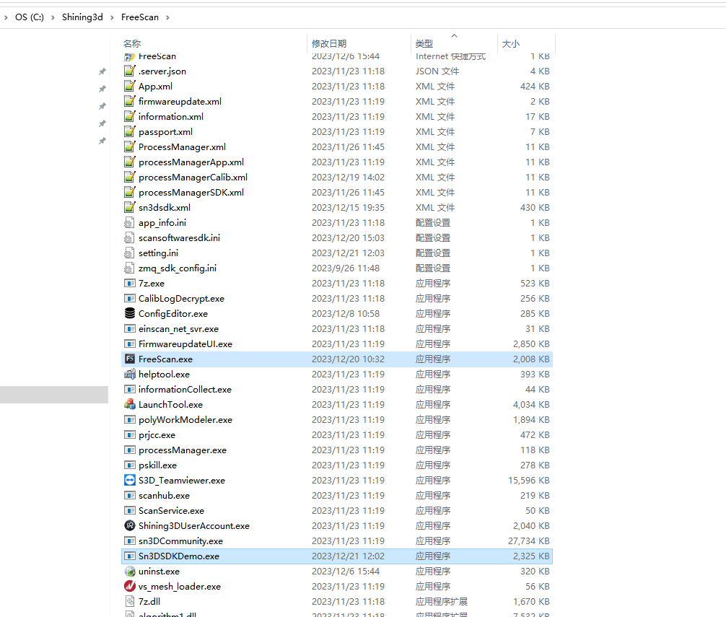

The second step is to modify configuration. SDK will wok in automation mode by default, in this mode, client application will startup with SDK, after your SDK invoking, the result will display in client application UI. The mode is suitable for client application extension, e.g. adding robert arm, read parameter from pressure board and other customize function.
You may change this mode by modifing scansoftwaresdk.ini, use left button double click it to open.
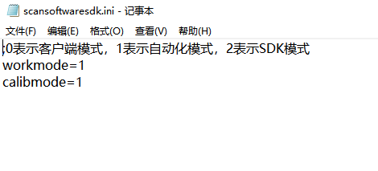
We change mode by workmode. 0 means client application mode, SDK function is disabled, the software is only work as normal application. 1 means automation mode described previously. 2 means SDK mode, client application UI isn’t displayed, user use their own code to show UI and realize the working steps.
Third, check runtime environment. If you want to verify your environment, please start Sn3DSDKDemo.exe in the working folder. Attention: Sn3DSDKDemo.exe is used for demonstration only, it doesn’t contain exception handling, DON’T operate it at will or it will cause unexpected action. Then select your own device in “Select your device” section, click “OK” button. Here take Freescan UE Pro as an example.

Wait a minute, you’ll see demo’s main UI, click “OpenService”.

You’ll see client application startup form. After that, the message box in bottom of Sn3DSDKDemo.exe’s main form will display initializing successfully information.
Click right up “Scan” button, switch to Scan panel.
Click “NewProject” button, like client application, choose a folder. You can see Sn3DSDKDemo.exe show scan panel and client application also upate scan mode.

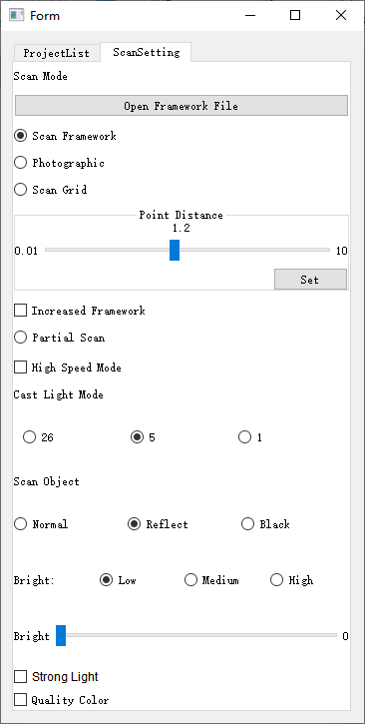

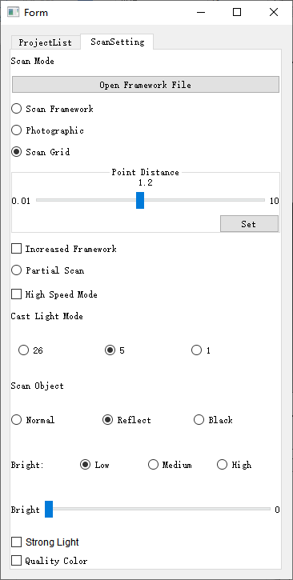
Click Sn3DSDKDemo.exe scan panel’s “Scan grid” option, switch to point cloud scanning.
Client application will switching synchronously:

Click Sn3DSDKDemo.exe center up “Scan” button(Attention: NOT right up sanme name button). If you can see point cloud, it means the environment is OK.
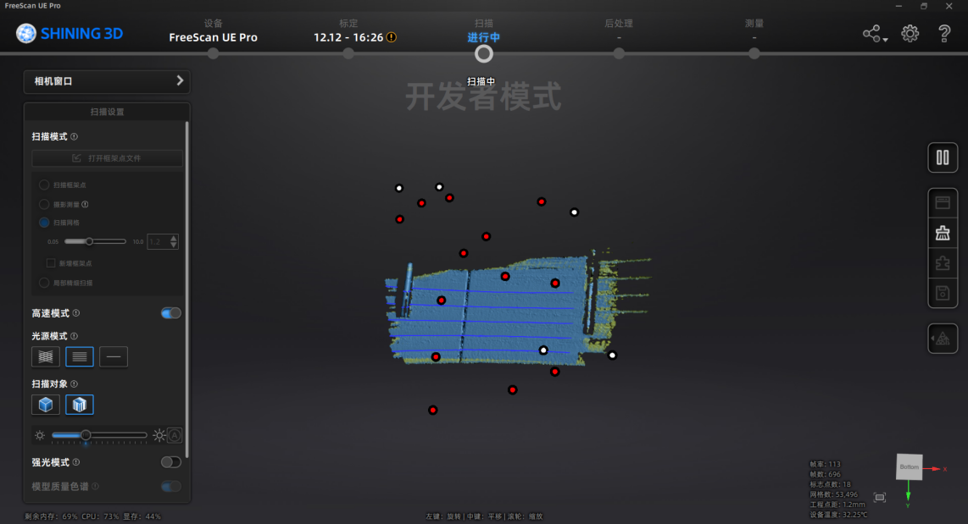

Build demo code
Building demo code will help you debug, and is good for development. The build environment need Visual Studio 2017、Qt5.15.10、CMake3.23.0 or the comiptible version.
After install that tools, run CMake-gui, choose right source and binary folder.

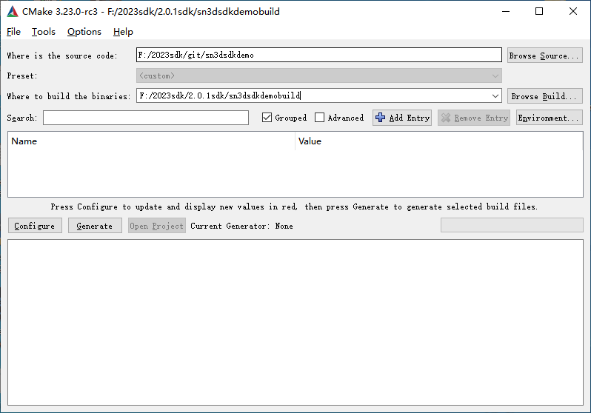
Click “Configure”Button.

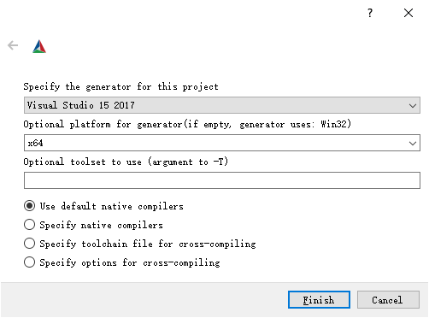
Choose Visual Studio 15 2017 and x64 platform, click “Finish”.
You’ll see following error information:

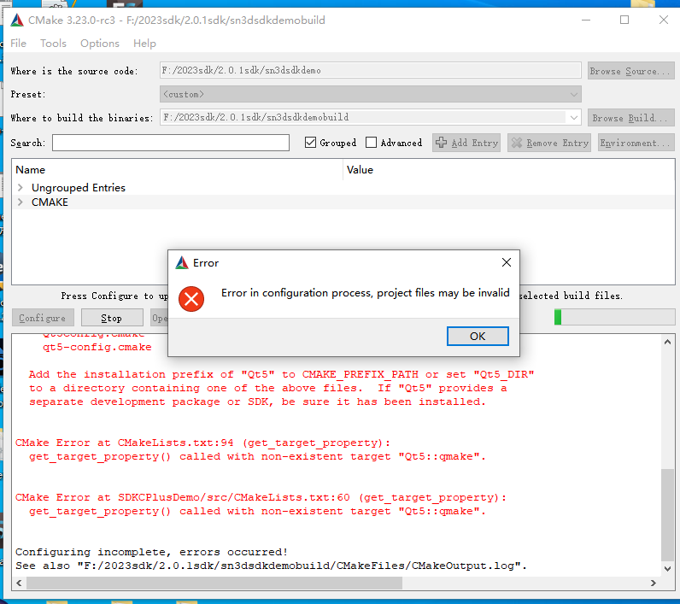

Click “OK” button, extend “Ungrouped Entries”, make sure “CUSTOMER_MODE” is checked. Click right side of Qt5_DIR, value column, select correct Qt5 cmake folder. The folder is different in different develop environment, it is often in Qt5 home folder\lib\cmake\Qt5. Click “Configure” again, you won’t see error message this time.
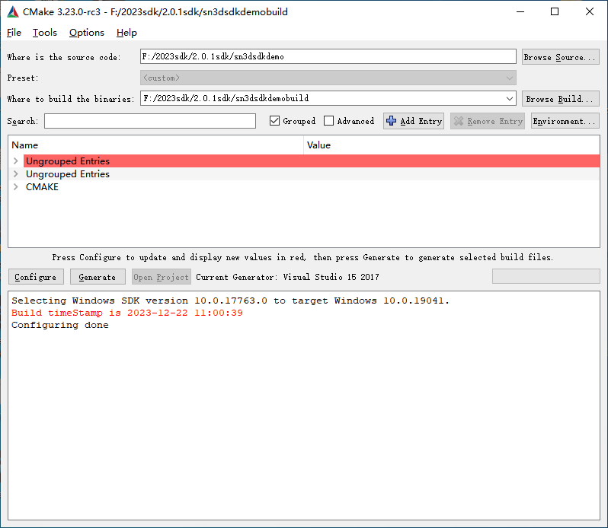
Click “Generate” to generate Visual Studio 2017 solution.

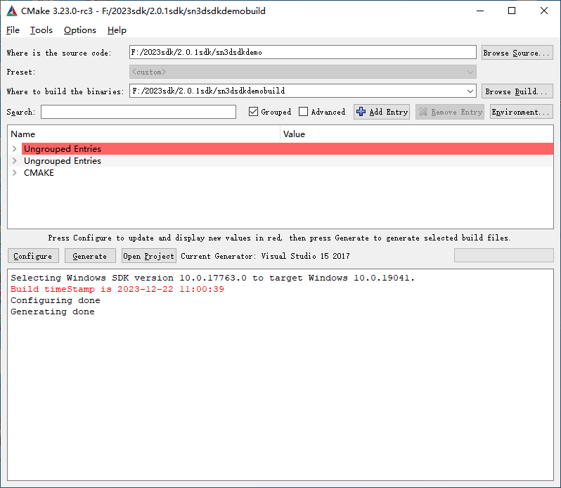
Click “Open project”, CMake will normally use Visual Studio 2017 to open the solution. Right click Sn3DSDKDemo project, click “build” in context menu, then following by normal Visual Studio 2017 develop steps.Attention: use Release, x64 configuration to compile.

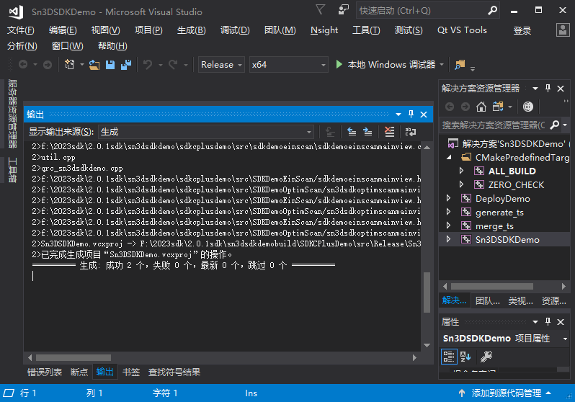
After sucessfully building your own Sn3DSDKDemo.exe, use it to replace our company’s file, then debug the software.

